1. Open Xampp Server
2. Start Apache
3. Start MySQL
4. Click on SQL Admin

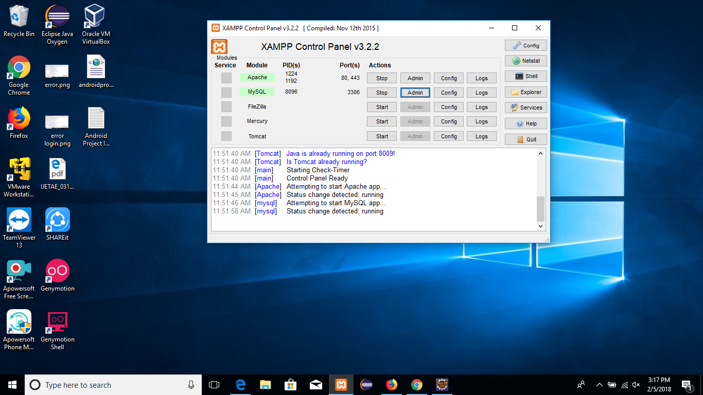

1. Click on New
2. Enter database name same as .sql file name.
3. Create

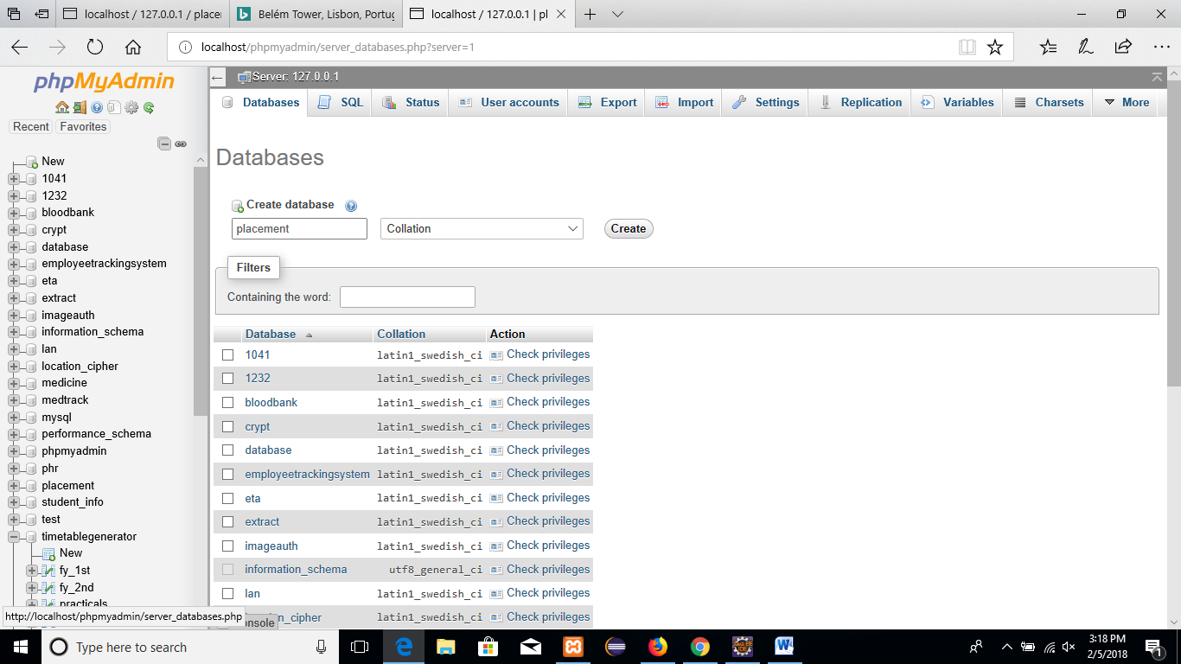

1. Click on Import
2. Browse the .sql file
3. Click on Go

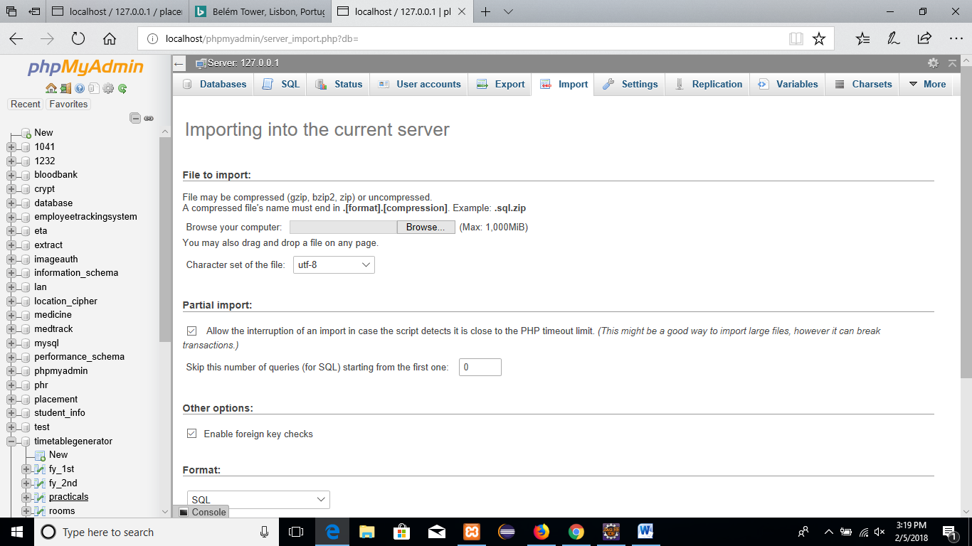

Your database successfully imported in PHPMyAdmin.